 

**PERSONAL EXPENSE TRACKER** **APPLICATION**

**IBM PROJECT REPORT**

SUBMITTED BY

ANEESH R A -962319104021

EZHIL ARASU -962319104038

SUTHISH KUMAR S -962319104093

ADITHYAN C P -962319104006

*in partial fulfillment for the award of the degree*

of

BACHELOR OF ENGINEERING

in

COMPUTER SCIENCE AND ENGINEERING

AMRITA COLLEGE OF ENGINEERING AND TECHNOLOGY ERACHAKULAM, NAGERCOIL.

ANNA UNIVERSITY::CHENNAI 600 025

JUNE 2022

**CERTIFICATE OF EVALUATION**

COLLEGE : AMRITA COLLEG OF ENGINEERING AND TECHNOLOGY

NAME

BRANCH : COMPUTER SCIENCE AND ENGINEERING

SEMESTER : VII

TITLE : PERSONAL EXPENSE TRACKER APPLICATION

TEAM ID : PNT2022TMID51917

**STUDENT NAMES REGISTRATION SUPERVISOR**

**NUMBER**

ANEESH R A -962319104021

EZHIL ARASU -962319104038 Mrs. JOTHI LAKSHMI S L

SUTHISH KUMAR S -962319104093

ADITHYAN C P -962319104006

The report of this project is submitted by the above students in partial fulfillment for the award of Bachelor of Engineering Degree, in Computer Science and Engineering of Anna University are evaluated and confirmed to the reports of the work done by the above students.

**MENTOR EVALUATOR**

# ACKNOWLEDGEMENT

First and foremost we would like to express our sincere gratitude to our respected Founder Amma,Mata Amritanandamayi Devi and Chairman Mr. K S Ramasubban IAS(Retd) for their blessings and grace in making our project great success.

We would like to place a record with deep sense of gratitude to our Honorable Principal Dr. T Kannan for having given us the opportunity to pursue B.E., course in this prestigious institution.

We would like to express our sincere thanks to our beloved Head of the Department Dr. P M Siva Raja and Project Coordinator Mrs. S L Jothi Lakshmi, for creating a supportive and a model environment for us to work and build up our innovative skills. We also thank our project Mentor Mrs. Sasikala T S for the kind encouragement and moral support, who has been a constant source of inspiration to us.

We wish to express our sincere sense of gratitude to Dr. P M Siva Raja, Head, Department of Computer Science and Engineering and to our Project Guide who enabled us to complete our project successfully.

**TABLE OF CONTENT**

**CHAPTER NO. TITLE**

1. **INTRODUCTION** 
   1. Project Overview

* 1. Purpose

1. **LITERATURE SURVEY** 
   1. Existing System
   2. References
   3. Problem Statement Definition
2. **IDEATION & PROPOSED SYSTEM** 
   1. Empathy Map Canvas
   2. Ideation &amp; Brainstorming
   3. Proposed Solution
   4. Problem Solution fit
3. **REQUIREMENT ANALYSIS** 
   1. Functional requirement
   2. Non-Functional requirements
4. **PROJECT DESIGN** 
   1. Data Flow Diagrams
   2. Solution &amp; Technical Architecture
   3. User Stories
5. **PROJECT PLANNING & SCHEDULING**
   1. Sprint Planning &amp; Estimation
   2. Sprint Delivery Schedule
6. **CODING & SOLUTIONING** 
   1. Feature 1
   2. Feature 2
7. **TESTING** 
   1. Test Cases
   2. User Acceptance Testing
8. **RESULTS** 
   1. Home Page
   2. Home-services
   3. Home-about
   4. Add expense
   5. Monthly limit
   6. Expense category
   7. Setting limit
   8. Result

1. **ADVANTAGES & DISADVANTAGES**
2. **CONCLUSION**
3. **FUTURE SCOPE**

**GitHub Link**

**Demo Link**

**CHAPTER 1**

# INTRODUCTION

## 1.1 Project Overview

This project is an attempt to manage our daily expenses in a more efficient and manageable way. Sometime we can’t remember where our money goes. And we can’t handle our cash flow. For this problem, we need a solution that everyone can manage their expenses. So we decided to find an easier way to get rid of this problem. So, our application attempts to free the user with as much as possible the burden of manual calculation and to keep the track of the expenditure. Instead of keeping a diary or a log of the expenses, this application enables the user to not just keep the control on the expenses but also to generate and save reports. With the help of this application, the user can manage their expenses on a daily, weekly and monthly basis. Users can insert and delete transactions as well as can generate and save their reports. The graphical representation of the application is the main part of the system as it appeals to the user more and is easy to understand.

## 1.2 Purpose

An expense tracker is a software or application that helps to keep an accurate record of your money inflow and outflow. Many people in India live on a fixed income, and they find that towards the end of the month they don't have sufficient money to meet their needs. So, for keep tracking on their income and expense this app was developed.

**CHAPTER 2**

**LITERATURE SURVEY**

## 2.1 Existing problem

The problem faced by today’s people are that they can’t even remember that how much they spend in their day to day expense and also they can’t make note of their all expenses. In this time there is no such perfect solution which helps a person to track their daily expenditure easily and efficiently and notify them about the money shortage they have. For making this they have maintained ledgers for the expense and income or computer logs is to maintain for such data and the calculation is done manually by the user, which may generate errors leading to the money loss. It is not complete tracking process.

## 2.2 Reference

1. <https://nevonprojects.com/daily-expense-tracker-system/>
2. <https://phpgurukul.com/daily-expense-tracker-using-php-and-mysql/>
3. <https://ijarsct.co.in/Paper391.pdf>
4. <https://kandi.openweaver.com/>

## 2.3 Problem Statement Definition

At the instant, there is no as such complete solution present easily or we should say free of cost which enables a person to keep a track of its daily expenditure easily. To do so a person has to keep a log in a diary or in a computer, also all the calculations needs to be done by the user which may sometimes results in errors leading to losses. Due to lack of a complete tracking system, there is a constant overload to rely on the daily entry of the expenditure and total estimation till the end of the month. As the name itself suggests, this project is an attempt to manage our daily expenses in a more efficient and manageable way. The system attempts to free the user with as much as possible the burden of manual calculation and to keep the track of the expenditure. Instead of keeping a dairy or a log of the expenses on the smartphones or laptops, this system enables the user to calculate the expenses accurately without any bugs. One of the drawbacks is the on-going maintenance, a lot of budget software offer the simplicity of integrating with all users financial accounts and consolidating their activity into one dashboard. However though, some of this existing software mostly have complicated features that are not user friendly.

**CHAPTER 3**

# IDEATION & PROPOSED SOLUTION

## 3.1 Empathy Map canvas

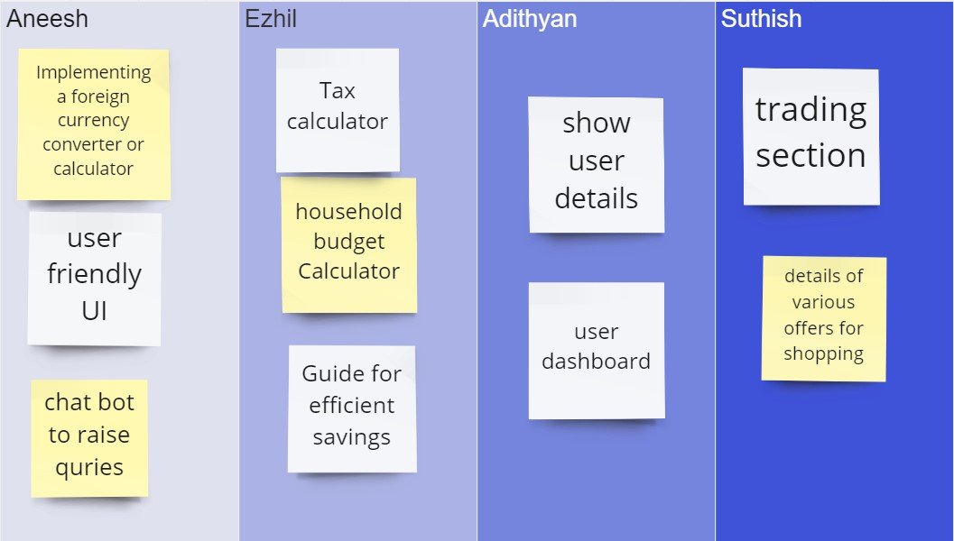

# 3.2 Ideation & Brainstorming

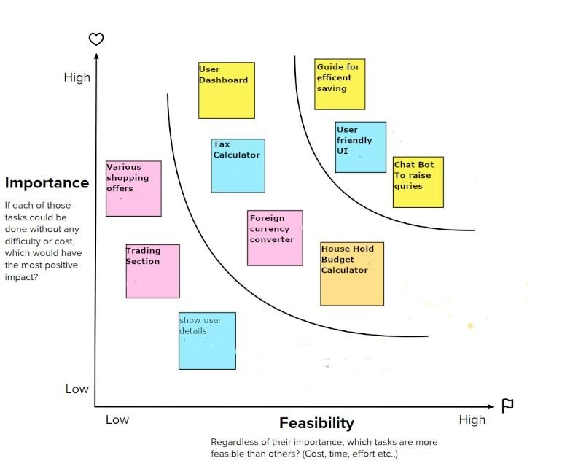

Our problem statement is about Expense Tracker, discussing this problem we team members came out with few solutions out of all the solutions we discussed we are here going to upload the top three ideas.

**IDEA 1:**

To reduce manual calculations, we propose an application. This application allows users to maintain a digital automated diary. Each user will be required to register on the system at registration time, the user will be provided id, which will be used to maintain the record of each unique user.

**IDEA 2:**

Expense Tracker application which will keep a track of Income-Expense of a user on a day to day basis. The best organizations have a way of tracking and handling these reimbursements. This ideal practice guarantees that the expenses tracked are accurately and in a timely manner.

**IDEA 3:**

From a company perspective, timely settlements of these expenses when tracked well will certainly boost employee’s morale. Additional feature of Expense and income prediction helps to better budget management.

## 3.3 Proposed Solution

|  |  |  |
| --- | --- | --- |
| **S.NO.** | **Parameter** | **Description** |
| 1. | Problem Statement | In paper-based expense tracker system it is difficult to track our monthly expenses manually. In paper-based expense tracker system it is difficult to track our monthly expenses manually. The paper-based expense records may get lost in case of fire accidents, flood etc. |
| 2. | Scalability of the  Solution | This application can handle large number of users and data with high performance and security. This application can adapt for both large-scale and small-scale purposes. Easily available in all kinds of devices. |
| 3. | Idea / Solution description | Daily expense management system which is specially designed for non-salaried and salaried personnel for keeping track of their daily expenditure with easy and effective way through computerized system which tends to eliminate manual paper works. Personal finance applications will ask users to add their expenses and based on their expenses wallet balance will be updated which will be visible to the user. They have an option to set a limit for the amount to be used for that particular month if the limit is exceeded the user will be notified with an email alert. |
| 4. | Novelty / Uniqueness | The user gets notified when their expense exceeds the limit and also it reminds the user when they |
|  |  | forgot to make entry. Tracking expenses through SMS. Data analytics on expenses. Future expense prediction |
| 5. | Social Impact /  Customer  Satisfaction | The application should be able to generate reports of their spending and notify users if they have exceeded their budget. It is designed to be dynamic to produce the prediction. It also provides users’ personal information, their income as well as their expenses. This application can create awareness among common people about finance and stuffs. This application also helps user to be financially responsible. It Reduces time rather than entering details manually. |
| 6. | Business Model  (Revenue Model) | This Application is provided for free of cost. But It will have some advertisement. In premium version there is no advertisement and contains some additional features. |

## 3.4 Proposed Solution Fit

The solution to this problem is, the user who spends more money can avoid unwanted expenses. The user can effectively spend their money for their essential needs.

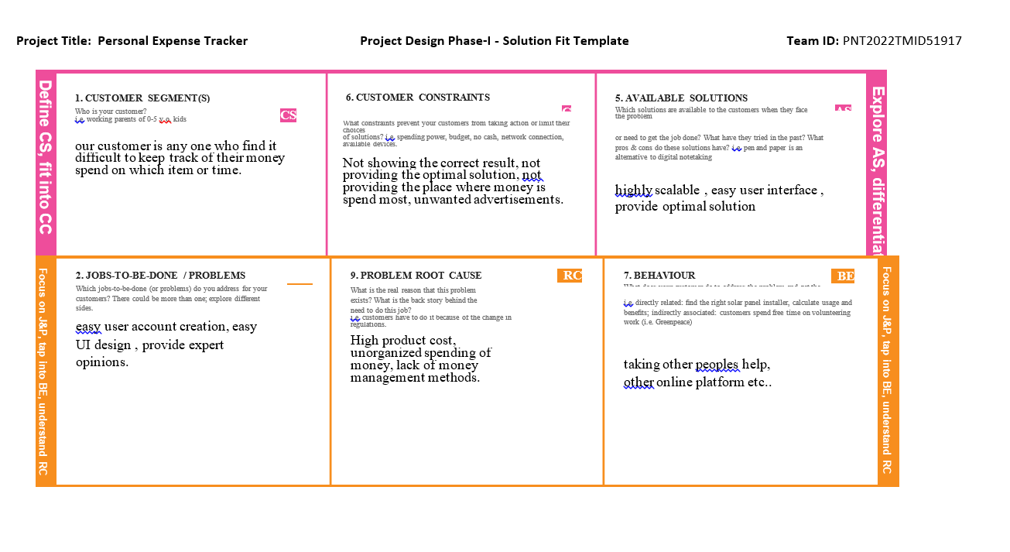

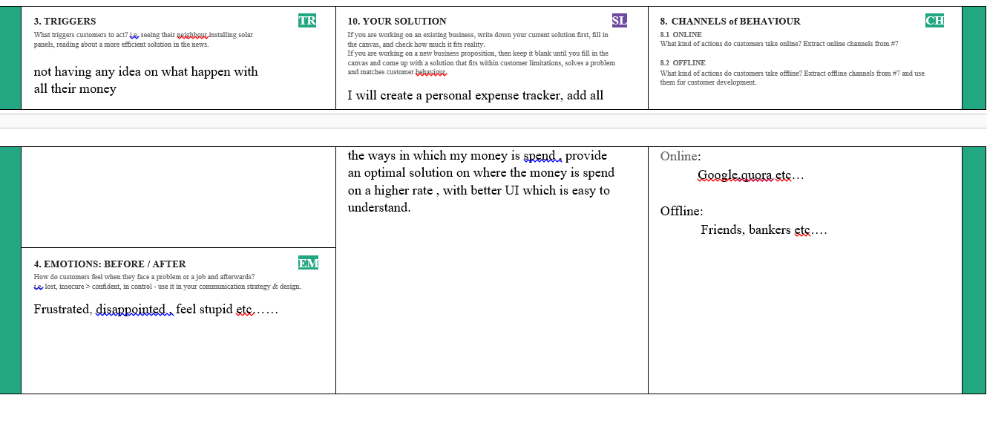

**CHAPTER 4**

# REQUIREMENT ANALYSIS

## 4.1 Functional requirement

Following are the functional requirements of the proposed solution.

|  |  |  |
| --- | --- | --- |
| **FR No.** | **Functional Requirement**  **(Epic)** | **Sub Requirement (Story / Sub-Task)** |
| 0FR-1 | User Registration | Form for collecting details |
| FR-2 | Login | Enter user name and password |
| FR-3 | Calendar | Personal expense tracker application must allow user to add the data to their expenses. |
| FR-4 | Expense Tracker | This application should graphically represent the expense in the form of report. |
| FR-5 | Report generation | Graphical representation of report must be generated. |
| FR-6 | Category | This application shall allow users to add categories of their expenses. |

## 4.2 Non-Functional requirement

Following are the non-functional requirements of the proposed solution.

|  |  |  |
| --- | --- | --- |
| **NFR No.** | **Non-Functional**  **Requirement** | **Description** |
| NFR-1 | **Usability** | Help to keep an accurate record of your income and expenses. |
| NFR-2 | **Security** | Budget tracking apps are considered very safe from those who commit cyber crimes. |
| NFR-3 | **Reliability** | Each data record is stored on a well built efficient database schema. There is no risk of data loss. |
| NFR-4 | **Performance** | The types of expense are categories along with an option. Through put of the system is increased due to light weight database support. |
| NFR-5 | **Availability** | The application must have a 100% up-time. |
| NFR-6 | **Scalability** | The ability to appropriately handle increasing demands. |

**CHAPTER 5**

# PROJECT DESIGN

## 5.1 Data Flow Diagrams

A Data Flow Diagram (DFD) is a traditional visual representation of the information flows within a system. A neat and clear DFD can depict the right amount of the system requirement graphically. It shows how data enters and leaves the system, what changes the information, and where data is stored.

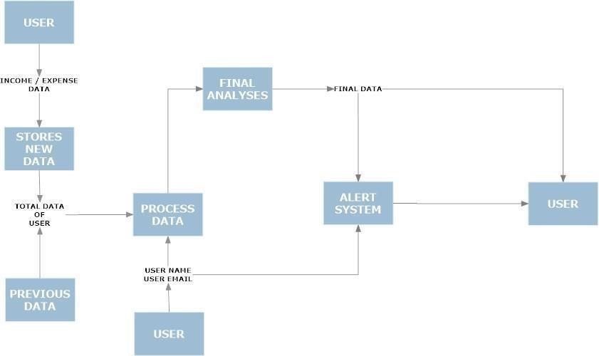

## 5.2 Solution & Technical Architecture

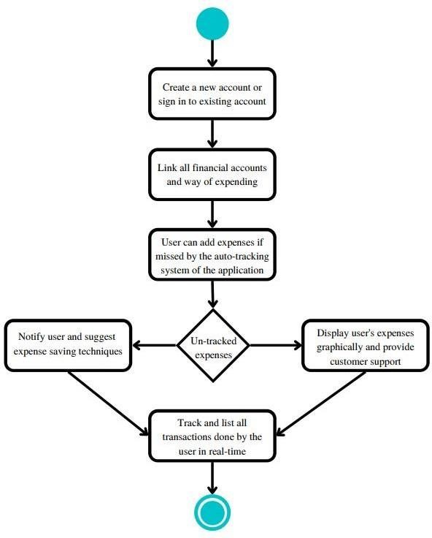

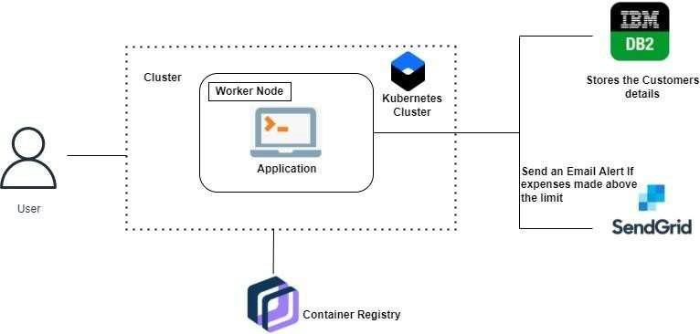

## 5.3 User Stories

Use the below template to list all the user stories for the product.

|  |  |  |  |  |  |
| --- | --- | --- | --- | --- | --- |
| **User Type** | **Functional Requirement (Epic)** | **User Story**  **Number** | **User Story / Task** | **Acceptance criteria** | **Priority** |
| Customer (Mobile user  &web  user) | Registration | USN-1 | As a user, I can register for the application by entering my email, password, and confirming my password. | I can access my account / dashboard | High |
|  |  | USN-2 | As a user, I will receive confirmation email once I have registered for the application | I can receive confir mation email & click confir m | High |
|  |  | USN- 3 | As a user, I can register for the | I can register & access the dashboard | Low |
|  |  |  | application through Facebook | with Facebook  Login |  |
|  | Login | USN - 4 | As a user, I can log into the application by entering email & password | I can access the applica tion | High |
|  | Dashboard | USN - 5 | As a user I can enter my income and expenditure details. | I can view my  daily expen  ses | High |
| Customer  Care  Executive |  | USN – 6 | As a customer care executive. I can solve the log in issues and other issues of the application. | I can provide support or solutio n at any time 24*7 | Medium |
| Administrator | Application | USN - 7 | As an administrator I can upgrade or update the application. customers  and users of the application | I can fix the bug which  arises for the customers and users of the application. | Medium |

**CHAPTER 6**

# PROJECT PLANNING & SCHEDULING

## 6.1 Sprint Planning & Estimation

|  |  |  |  |  |  |  |
| --- | --- | --- | --- | --- | --- | --- |
| **Sprint** | **Functional**  **Requirement (Epic)** | **User Story Number** | **User Story / Task** | **Story Points** | **Priority** | **Team Members** |
| Sprint-1 | Registration,Login | USN-1 | As a user, I can register for the application by entering my email, password, and confirming my password. | 2 | High | Aneesh  Suthish |
|  |  | USN-2 | As a user, I will receive confirmation email once I have registered for the application | 1 | High | Ezhil |
|  | login | USN-3 | As a user, I can log into the application by entering email & password | 1 | high | Adithyan |
| Sprint-1 | Dashboard | USN-4 | Logging in takes to the dashboard for the logged user. | 2 | High | Aneesh |
| Sprint-2 | Work Space, | USN-1 | Workspace for personal expense tracking | 2 | high | Aneesh |
|  | charts | USN=2 | Creating various graphs and statistics of customer’s data | 1 | medium | Ezhil |
| Sprint-2 | Connecting to IBM DB2 | USN-3 | Linking database with dashboard | 2 | High | Adhithyan |
|  |  | USN=4 | Making dashboard interactive with JS | 2 | HIGH | Suthish |
| Sprint-3 |  | USN-1 | Wrapping up the server side works of frontend | 1 | Medium | suthish |
| Sprint-3 | Watson Assistant | USN-2 | Creating Chatbot for expense tracking and for clarifying user’s query | 1 | Medium | Aneesh  Suthish |
| Sprint-3 | Send Grid | USN-3 | Using SendGrid to send mail to the user about their expenses | 1 | low | Adithyan |
| Sprint-3 |  | USN-4 | Integrating both frontend and backend | 2 | high | Aneesh  Suthish |
| Sprint-4 | Docker | USN-1 | Creating image of website using docker | 2 | High | Suthish |
| Sprint-4 | Cloud Registry | USN-2 | Uploading docker image to IBM Cloud registry | 2 | high | Ezhil |
|  |  | USN-3 | Create container using the docker image and hosting the site | 2 | high | Adithyan |
|  | kubernetes |  |  |  |  |  |
|  | exposing | USN-4 | Exposing IP/Ports for the site | 2 | high | Aneesh  Suthish |

## 6.2 Sprint Delivery Schedule

|  |  |  |  |  |  |  |
| --- | --- | --- | --- | --- | --- | --- |
| **Sprint** | **Total**  **Story**  **Points** | **Duration** | **Sprint Start**  **Date** | **Sprint End**  **Date**  **(Planned)** | **Story**  **Points**  **Completed**  **(as on Planned**  **End Date)** | **Sprint**  **Release**  **Date**  **(Actual)** |
| Sprint-1 | 20 | 6Days | 23 Oct 2022 | 28 Oct 2022 | 20 | 29Oct 2022 |
| Sprint-2 | 20 | 6 Days | 30 Oct 2022 | 04 Nov 2022 | 20 | 05 Nov 2022 |
| Sprint-3 | 20 | 6 Days | 06 Nov 2022 | 11 Nov 2022 | 20 | 12 Nov 2022 |
| Sprint-4 | 20 | 6 Days | 13 Nov 2022 | 18 Nov 2022 | 20 | 19 Nov 2022 |

**CHAPTER 7**

# Coding And Solutioning

**7.1. Features**

## Feature 1: Add Expense

**Feature 2:** Update expense

**Feature 3:** Delete Expense

## Feature 4: Set Limit

**Feature 5:** Send Alert Emails to users

**7.2. Other Features:**

Track your expenses anywhere, anytime. Seamlessly manage your money and budget without any financial paperwork. Just click and submit your invoices and expenditures. Access, submit, and approve invoices irrespective of time and location. Avoid data loss by scanning your tickets and bills and saving in the app. Approval of bills and expenditures in real-time and get notified instantly. Quick settlement of claims and reduced human errors with an automated and streamlined billing process.

**Codes:**

import OS import calendar from flask import request, session from flask session import Session from sql alchemy import create engine from sql alchemy.orm import scoped_session, sessionmaker from datetime import datetime from helpers import convertSQLToDict

# Create engine object to manage connections to DB, and scoped session to separate user interactions with DB

engine = create_engine(os.getenv("DATABASE_URL")) db = scoped_session(sessionmaker(bind=engine))

# Add expense(s) to the users expense records

# There are two entry points for this: 1) 'addexpenses' route and 2) 'index' route. #1 allows many expenses whereas #2 only allows 1 expense per POST. def addExpenses(formData, userID):

expenses = [] expense = {"description": None, "category": None, "date": None, "amount": None, "payer": None}

# Check if the user is submitting via 'addexpenses' or 'index' route - this determines if a user is adding 1 or potentially many expenses in a single

POST

if "." not in formData[0][0]: for key, value in formData: # Add to dictionary expense[key] = value.strip()

# Convert the amount from string to float for the DB expense["amount"] = float(expense["amount"])

# Add dictionary to list (to comply with design/standard of expensed.html)

expenses.append(expense)

# User is submitting via 'addexpenses' route

else:

counter = 0 for key, value in formData:

# Keys are numbered by default in HTML form. Remove those numbers so we can use the HTML element names as keys for the dictionary. cleanKey = key.split(".")

# Add to dictionary

expense[cleanKey[0]] = value.strip()

# Every 5 loops add the expense to the list of expenses (because there are 5 fields for an expense record)

counter += 1 if counter % 5 == 0:

# Store the amount as a float

expense["amount"] = float(expense["amount"])

# Add dictionary to list

expenses.append(expense.copy())

# Insert expenses into DB for expense in expenses:

now = datetime.now().strftime("%m/%d/%Y %H:%M:%S") db.execute("INSERT INTO expenses (description, category, expenseDate, amount, payer, submitTime, user_id) VALUES (:description, :category, :expenseDate, :amount, :payer, :submitTime, :usersID)", {"description": expense["description"], "category": expense["category"], "expenseDate": expense["date"], "amount": expense["amount"], "payer": expense["payer"], "submitTime": now,

"usersID": userID})

db.commit()

return expenses

# Get and return the users lifetime expense history def getHistory(userID): results = db.execute("SELECT description, category, expenseDate AS date, payer, amount, submitTime FROM expenses WHERE user_id =

:usersID ORDER BY id ASC",

{"usersID": userID}).fetchall()

history = convertSQLToDict(results)

return history

# Get and return an existing expense record with ID from the DB def getExpense(formData, userID): expense = {"description": None, "category": None,

"date": None, "amount": None, "payer": None, "submitTime":

None, "id": None} expense["description"] = formData.get("oldDescription").strip() expense["category"] = formData.get("oldCategory").strip() expense["date"] = formData.get("oldDate").strip() expense["amount"] = formData.get("oldAmount").strip() expense["payer"] = formData.get("oldPayer").strip() expense["submitTime"] = formData.get("submitTime").strip()

# Remove dollar sign and comma from the old expense so we can convert to float for the DB expense["amount"] = float(

expense["amount"].replace("$", "").replace(",", ""))

# Query the DB for the expense unique identifier

expenseID = db.execute("SELECT id FROM expenses WHERE user_id = :usersID AND description = :oldDescription AND category = :oldCategory AND expenseDate = :oldDate AND amount = :oldAmount AND payer = :oldPayer AND submitTime = :oldSubmitTime",

{"usersID": userID, "oldDescription": expense["description"], "oldCategory": expense["category"], "oldDate": expense["date"], "oldAmount": expense["amount"], "oldPayer":

expense["payer"], "oldSubmitTime": expense["submitTime"]}).fetchone()

# Make sure a record was found for the expense otherwise set as None if expenseID: expense["id"] = expenseID[0] else:

expense["id"] = None

return expense

# Delete an existing expense record for the user def deleteExpense(expense, userID): result = db.execute("DELETE FROM expenses WHERE user_id =

:usersID AND id = :oldExpenseID",

{"usersID": userID, "oldExpenseID": expense["id"]}) db.commit()

return result

# Update an existing expense record for the user def updateExpense(oldExpense, formData, userID): expense = {"description": None, "category": None, "date": None, "amount": None, "payer": None} expense["description"] = formData.get("description").strip() expense["category"] = formData.get("category").strip() expense["date"] = formData.get("date").strip() expense["amount"] = formData.get("amount").strip() expense["payer"] = formData.get("payer").strip()

# Convert the amount from string to float for the DB expense["amount"] = float(expense["amount"])

# Make sure the user actually is submitting changes and not saving the existing expense again hasChanges = False for key, value in oldExpense.items():

# Exit the loop when reaching submitTime since that is not something the user provides in the form for a new expense if key == "submitTime": break else: if oldExpense[key] != expense[key]: hasChanges = True break if hasChanges is False: return None

# Update the existing record

now = datetime.now().strftime("%m/%d/%Y %H:%M:%S") result = db.execute("UPDATE expenses SET description = :newDescription, category = :newCategory, expenseDate = :newDate, amount = :newAmount, payer = :newPayer, submitTime = :newSubmitTime

WHERE id = :existingExpenseID AND user_id = :usersID",

{"newDescription": expense["description"], "newCategory": expense["category"], "newDate": expense["date"], "newAmount":

expense["amount"], "newPayer": expense["payer"], "newSubmitTime": now, "existingExpenseID": oldExpense["id"], "usersID": userID}).rowcount db.commit()

# Make sure result is not empty (indicating it could not update the expense) if result:

# Add dictionary to list (to comply with design/standard of expensed.html)

expenses = [] expenses.append(expense)

return expenses else:

return None import os import calendar import copy import expenze_expenses import expenze_dashboard import expenze_categories

import expenze_budgets

from flask import request, session from flask_session import Session from sqlalchemy import create_engine

from sqlalchemy.orm import scoped_session, sessionmaker from helpers import convertSQLToDict from datetime import datetime

# Create engine object to manage connections to DB, and scoped session to separate user interactions with DB

engine = create_engine(os.getenv("DATABASE_URL")) db = scoped_session(sessionmaker(bind=engine))

# Generates data needed for the budget report by looping through each budget and adding expense history where categories match between budgets and expenses

# TODO: This data/reporting becomes less beneficial when users have multiple budgets that have the same categories checked because 1 expense with 'Category A' will be associated with for example 3 budgets that have

'Category A' checked def generateBudgetsReport(userID, year=None):

# Create data structure to hold users category spending data budgetsReport = []

# Default to getting current years budgets if not year:

year = datetime.now().year

# Get every budgets spent/remaining for the user

budgetsReport = expenze_dashboard.getBudgets(userID, year)

# Loop through the budgets and add a new key/value pair to hold expense details per budget if budgetsReport: for record in budgetsReport:

budgetID = expenze_budgets.getBudgetID(record["name"], userID) results = db.execute("SELECT expenses.description,

expenses.category, expenses.expenseDate, expenses.payer, expenses.amount FROM expenses WHERE user_id = :usersID AND date_part('year', date(expensedate)) = :year AND category IN (SELECT categories.name FROM budgetcategories INNER JOIN categories on budgetcategories.category_id = categories.id WHERE budgetcategories.budgets_id = :budgetID)",

{"usersID": userID, "year": year, "budgetID":

budgetID}).fetchall()

expenseDetails = convertSQLToDict(results) record["expenses"] = expenseDetails

return budgetsReport

# Generates data needed for the monthly spending report

def generateMonthlyReport(userID, year=None):

# Default to getting current years reports if not year:

year = datetime.now().year

# Create data structure to hold users monthly spending data for the chart

(monthly summed data)

spending_month_chart = expenze_dashboard.getMonthlySpending(userID, year)

# Get the spending data from DB for the table (individual expenses per month)

results = db.execute(

"SELECT description, category, expensedate, amount, payer FROM expenses WHERE user_id = :usersID AND date_part('year', date(expensedate)) = :year ORDER BY id ASC", {"usersID": userID, "year":

year}).fetchall()

spending_month_table = convertSQLToDict(results)

# Combine both data points (chart and table) into a single data structure

monthlyReport = {"chart": spending_month_chart,

"table": spending_month_table}

return monthlyReport

# Generates data needed for the spending trends report def generateSpendingTrendsReport(userID, year=None):

# Default to getting current years reports if not year:

year = datetime.now().year

# Get chart data for spending trends

spending_trends_chart = expenze_dashboard.getSpendingTrends(userID, year)

# Data structure for spending trends table

categories = []

category = {"name": None, "expenseMonth": 0, "expenseCount": 0, "amount": 0}

spending_trends_table = {

"January": [],

"February": [],

"March": [],

"April": [],

"May": [],

"June": [],

"July": [],

"August": [],

"September": [],

"October": [],

"November": [],

"December": []

}

# Get all of the users categories first (doesn't include old categories the user deleted but are still tracked in Expenses)

categories_active = expenze_categories.getSpendCategories(userID)

# Get any categories that are in expenses but no longer exist as a selectable category for the user (because they deleted the category) categories_inactive =

expenze_categories.getSpendCategories_Inactive(userID)

# First fill using the users current categories, and then inactive categories from Expenses

for activeCategory in categories_active: category["name"] = activeCategory["name"] categories.append(category.copy())

for inactiveCategory in categories_inactive: category["name"] = inactiveCategory["category"] categories.append(category.copy())

# Place a deep copy of the categories into each month (need deep copy here because every category may have unique spend data month to month. TODO: optimize this for memory/performance later) for month in spending_trends_table.keys(): spending_trends_table[month] = copy.deepcopy(categories)

# Get expense data for each category by month (retrieves the total amount of expenses per category by month, and the total count of expenses per category by month. Assumes there is at least 1 expense for the category) results = db.execute(

"SELECT date_part('month', date(expensedate)) AS monthofcategoryexpense, category AS name, COUNT(category) AS count,

SUM(amount) AS amount FROM expenses WHERE user_id = :usersID AND date_part('year', date(expensedate)) = :year GROUP BY date_part('month', date(expensedate)), category ORDER BY

COUNT(category) DESC",

{"usersID": userID, "year": year}).fetchall()

spending_trends_table_query = convertSQLToDict(results)

# Loop thru each monthly category expense from above DB query and update the data structure that holds all monthly category expenses for categoryExpense in spending_trends_table_query: # Get the key (month) for the data structure monthOfExpense = calendar.month_name[int( categoryExpense["monthofcategoryexpense"])]

# Traverse the data structure: 1) go to the dict month based on the category expense date, 2) loop thru each dict category until a match in name occurs with the expense, 3) update the dict month/amount/count properties to match the DB record for category in spending_trends_table[monthOfExpense]: if category["name"] == categoryExpense["name"]: category["expenseMonth"] = categoryExpense["monthofcategoryexpense"]

category["expenseCount"] = categoryExpense["count"] category["amount"] = categoryExpense["amount"] break else: continue

# Calculates and stores the amount spent per category for the table (note: can't get this to work in jinja with the spending_trends_table dict because of how jinja scopes variables. TODO: rethink data-structure to combine these) numberOfCategories = len(categories)

categoryTotal = 0

# Loops through every month per category and sums up the monthly amounts for i in range(numberOfCategories):

for month in spending_trends_table.keys(): categoryTotal += spending_trends_table[month][i]["amount"] categories[i]["amount"] = categoryTotal categoryTotal = 0

# Combine both data points (chart, table, categories) into a single data structure

spendingTrendsReport = {"chart": spending_trends_chart,

"table": spending_trends_table, "categories": categories} return spendingTrendsReport

# Generates data needed for the payers spending report def generatePayersReport(userID, year=None):

# Default to getting current years reports if not year:

year = datetime.now().year

# First get all of the payers from expenses table (this may include payers that don't exist anymore for the user (i.e. deleted the payer and didn't update expense records))

results_payers = db.execute(

"SELECT payer AS name, SUM(amount) AS amount FROM expenses

WHERE user_id = :usersID AND date_part('year', date(expensedate)) = :year GROUP BY payer ORDER BY amount DESC", {"usersID": userID, "year": year}).fetchall()

payers = convertSQLToDict(results_payers)

# Now get any payers the user has in their account but haven't expensed anything

results_nonExpensePayers = db.execute(

"SELECT name FROM payers WHERE user_id = :usersID AND name NOT IN (SELECT payer FROM expenses WHERE expenses.user_id = :usersID AND date_part('year', date(expensedate)) = :year)", {"usersID": userID, "year": year}).fetchall()

nonExpensePayers = convertSQLToDict(results_nonExpensePayers)

# Add the non-expense payers to the payers data structure and set their amounts to 0 for payer in nonExpensePayers: newPayer = {"name": payer["name"], "amount": 0} payers.append(newPayer)

# Calculate the total paid for all payers combined

totalPaid = 0

for payer in payers: totalPaid = totalPaid + payer["amount"]

# Calculate the % paid per payer and add to the data structure if totalPaid != 0: for payer in payers:

payer["percentAmount"] = round((payer["amount"] / totalPaid) * 100)

return payers else:

return None from flask import request, session from flask_session import Session from sqlalchemy import create_engine

from sqlalchemy.orm import scoped_session, sessionmaker from helpers import convertSQLToDict

# Create engine object to manage connections to DB, and scoped session to separate user interactions with DB

engine = create_engine(os.getenv("DATABASE_URL")) db = scoped_session(sessionmaker(bind=engine))

# Gets and return the users spend categories def getSpendCategories(userID):

results = db.execute(

"SELECT categories.name FROM usercategories INNER JOIN categories ON usercategories.category_id = categories.id WHERE usercategories.user_id = :usersID",

{"usersID": userID}).fetchall() categories = convertSQLToDict(results) return categories

# Gets and return the users *inactive* spend categories from their expenses (e.g. they deleted a category and didn't update their expense records that still use the old category name) def getSpendCategories_Inactive(userID):

results = db.execute(

"SELECT category FROM expenses WHERE user_id = :usersID AND category NOT IN(SELECT categories.name FROM usercategories INNER JOIN categories ON categories.id = usercategories.category_id WHERE user_id = :usersID) GROUP BY category",

{"usersID": userID}).fetchall()

categories = convertSQLToDict(results)

return categories

# Get and return all spend categories from the category library def getSpendCategoryLibrary():

results = db.execute("SELECT id, name FROM categories").fetchall()

convertSQLToDict(results)

return categories

# Get and return the name of a category from the library def getSpendCategoryName(categoryID):

name = db.execute(

"SELECT name FROM categories WHERE id = :categoryID",

{"categoryID": categoryID}).fetchone()[0]

return name

# Gets and return the users budgets, and for each budget the categories they've selected def getBudgetsSpendCategories(userID): results = db.execute("SELECT budgets.name AS budgetname, categories.id AS categoryid, categories.name AS categoryname FROM budgetcategories INNER JOIN budgets on budgetcategories.budgets_id = budgets.id INNER JOIN categories on budgetcategories.category_id = categories.id WHERE budgets.user_id = :usersID ORDER BY budgets.name, categories.name",

{"usersID": userID}).fetchall()

budgetsWithCategories = convertSQLToDict(results)

return budgetsWithCategories

# Gets and returns the users budgets for a specific category ID def getBudgetsFromSpendCategory(categoryID, userID): results = db.execute("SELECT budgets.id AS budgetid, budgets.name AS budgetname, categories.id AS categoryid, categories.name AS categoryname FROM budgetcategories INNER JOIN budgets on budgetcategories.budgets_id = budgets.id INNER JOIN categories on budgetcategories.category_id = categories.id WHERE budgets.user_id = :usersID AND budgetcategories.category_id = :categoryID ORDER BY budgets.name, categories.name", {

"usersID": userID, "categoryID": categoryID}).fetchall()

budgets = convertSQLToDict(results) return budgets

# Updates budgets where an old category needs to be replaced with a new one (e.g. renaming a category) def updateSpendCategoriesInBudgets(budgets, oldCategoryID, newCategoryID): for budget in budgets:

# Update existing budget record with the new category ID db.execute("UPDATE budgetcategories SET category_id = :newID WHERE budgets_id = :budgetID AND category_id = :oldID",

{"newID": newCategoryID, "budgetID": budget["budgetid"],

"oldID": oldCategoryID})

db.commit()

# Updates budgets where a category needs to be deleted def deleteSpendCategoriesInBudgets(budgets, categoryID): for budget in budgets:

# Delete existing budget record with the old category ID

db.execute("DELETE FROM budgetcategories WHERE budgets_id =

:budgetID AND category_id = :categoryID",

{"budgetID": budget["budgetid"], "categoryID": categoryID})

db.commit()

# Generates a ditionary containing all spend categories and the budgets associated with each category def generateSpendCategoriesWithBudgets(categories, categoryBudgets):

categoriesWithBudgets = []

# Loop through every category for category in categories:

# Build a dictionary to hold category ID + Name, and a list holding all the budgets which have that category selected

categoryWithBudget = {"name": None, "budgets": []} categoryWithBudget["name"] = category["name"]

# Insert the budget for the spend category if it exists for budget in categoryBudgets: if category["name"] == budget["categoryname"]: categoryWithBudget["budgets"].append(budget["budgetname"])

# Add the completed dict to the list

categoriesWithBudgets.append(categoryWithBudget)

return categoriesWithBudgets

# Checks if the category name exists in the 'library' or 'registrar' (categories table) - if so, return the ID for it so it can be passed to below add def existsInLibrary(newName):

# Query the library for a record that matches the name row = db.execute(

"SELECT * FROM categories WHERE LOWER(name) = :name",

{"name": newName.lower()}).fetchone()

if row:

return True else: return False

# Get category ID from DB def getCategoryID(categoryName, userID=None):

# If no userID is supplied, then it's searching the category library if userID is None:

categoryID = db.execute(

"SELECT id FROM categories WHERE LOWER(name) = :name",

{"name": categoryName.lower()}).fetchone()

if not categoryID: return None else:

return categoryID["id"]

# Otherwise search the users selection of categories else:

categoryID = db.execute(

"SELECT categories.id FROM usercategories INNER JOIN categories ON usercategories.category_id = categories.id WHERE usercategories.user_id = :usersID AND LOWER(categories.name) = :name", {"usersID": userID, "name": categoryName.lower()}).fetchone()

if not categoryID: return None else:

return categoryID["id"]

# Checks if the category name exists in the users seleciton of categories (usercategories table) - if so, just return as False? def existsForUser(newName, userID):

# Query the library for a record that matches the name row = db.execute(

"SELECT categories.id FROM usercategories INNER JOIN categories ON usercategories.category_id = categories.id WHERE

usercategories.user_id = :usersID AND LOWER(categories.name) = :name", {"usersID": userID, "name": newName.lower()}).fetchone()

if row: return True else: return False

# Adds a category to the database (but not to any specific users account) def addCategory_DB(newName):

# Create a new record in categories table categoryID = db.execute(

"INSERT INTO categories (name) VALUES (:name) RETURNING id",

{"name": newName}).fetchone()[0]

db.commit()

return categoryID

# Adds a category to the users account def addCategory_User(categoryID, userID): db.execute("INSERT INTO usercategories (user_id, category_id)

VALUES (:usersID, :categoryID)",

{"usersID": userID, "categoryID": categoryID}) db.commit()

# Deletes a category from the users account def deleteCategory_User(categoryID, userID): db.execute("DELETE FROM usercategories WHERE user_id = :usersID

AND category_id = :categoryID",

{"usersID": userID, "categoryID": categoryID}) db.commit()

# Update just the spend categories of expense records (used for category renaming)

def updateExpenseCategoryNames(oldCategoryName, newCategoryName, userID):

db.execute("UPDATE expenses SET category = :newName WHERE user_id = :usersID AND category = :oldName",

{"newName": newCategoryName, "usersID": userID, "oldName":

oldCategoryName})

db.commit()

# Rename a category def renameCategory(oldCategoryID, newCategoryID, oldCategoryName, newCategoryName, userID):

# Add the renamed category to the users account addCategory_User(newCategoryID, userID)

# Delete the old category from their account

deleteCategory_User(oldCategoryID, userID)

# Update users budgets (if any exist) that are using the old category to the new one

budgets = getBudgetsFromSpendCategory(oldCategoryID, userID)

if budgets:

updateSpendCategoriesInBudgets(budgets, oldCategoryID, newCategoryID)

# Update users expense records that are using the old category to the new one

updateExpenseCategoryNames(oldCategoryName, newCategoryName, userID)

# Delete a category def deleteCategory(categoryID, userID): # Get budgets that are currently using the category they want to delete budgets = getBudgetsFromSpendCategory(categoryID, userID)

# Delete categories from the users budgets if budgets:

deleteSpendCategoriesInBudgets(budgets, categoryID)

# Delete the category from the users account deleteCategory_User(categoryID, userID)

**CHAPTER 8**

# TESTING

**8.1. TESTING:**

* Login Page (Functional)
* Login Page (UI)
* Add Expense Page (Functional)

**8.2. User Acceptance Testing:**

## 1. Purpose of Document

The purpose of this document is to briefly explain the test coverage and open issues of the [ProductName] project at the time of the release to User Acceptance Testing (UAT).

## 2. Defect Analysis

This report shows the number of resolved or closed bugs at each severity level, and how they were resolved

|  |  |  |  |  |  |
| --- | --- | --- | --- | --- | --- |
| **Resolution** | **Severity 1** | **Severity 2** | **Severity 3** | **Severity 4** | **Subtotal** |
| By Design | 11 | 4 | 2 | 3 | 20 |
| Duplicate | 1 | 0 | 3 | 0 | 4 |
| External | 2 | 3 | 0 | 1 | 6 |
| Fixed | 11 | 2 | 5 | 20 | 38 |
| Not  Reproduce | 0 | 0 | 1 | 0 | 1 |
| Skipped | 0 | 0 | 1 | 1 | 2 |
| Won't Fix | 0 | 5 | 2 | 1 | 8 |
| Totals | 25 | 14 | 12 | 26 | 84 |

## 3. Test Case Analysis

This report shows the number of test cases that have passed, failed, and untested

|  |  |  |  |  |
| --- | --- | --- | --- | --- |
| **Section** | **Total Cases** | **Not Tested** | **Fail** | **Pass** |
| Print Engine | 10 | 0 | 0 | 10 |
| Client Application | 50 | 0 | 0 | 50 |
| Security | 1 | 0 | 0 | 1 |
| Outsource Shipping | 3 | 0 | 0 | 3 |
| Exception Reporting | 8 | 0 | 0 | 8 |
| Final Report Output | 4 | 0 | 0 | 4 |
| Version Control | 2 | 0 | 0 | 2 |

**CHAPTER 9**

# RESULTS

**9.1 Home Page**

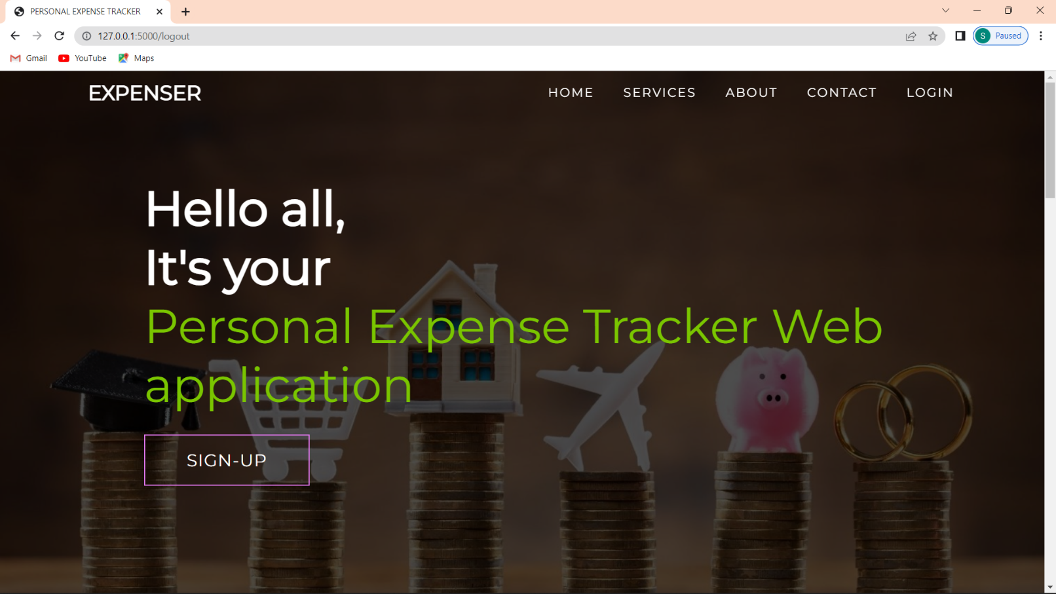

**9.2 Home-services**

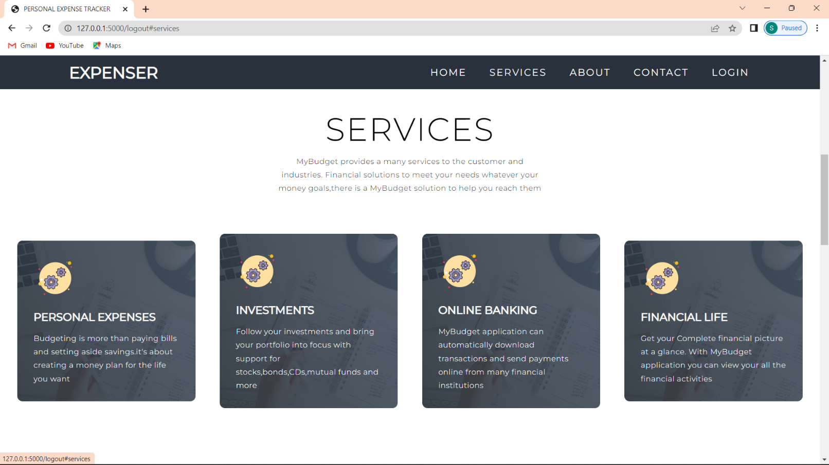

## 9.3 Sign in Page

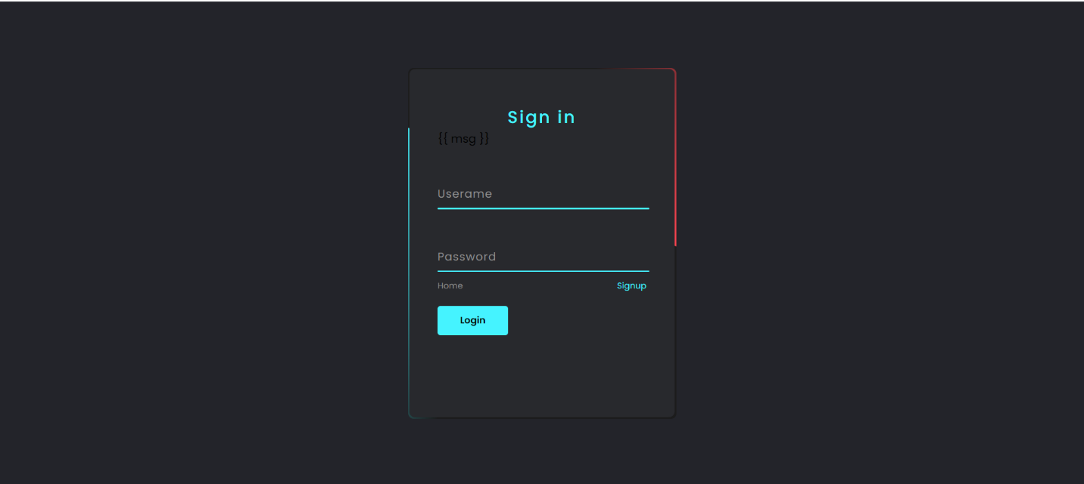

**9.4 Home - About**

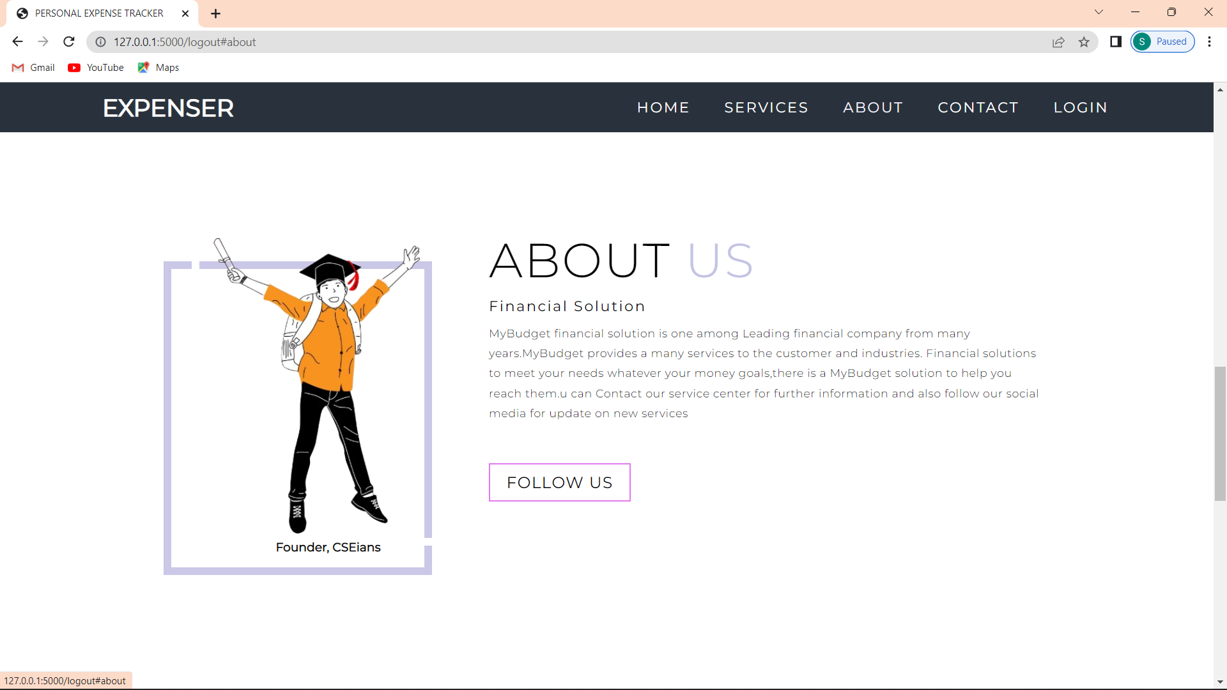

## 9.5 Add expense

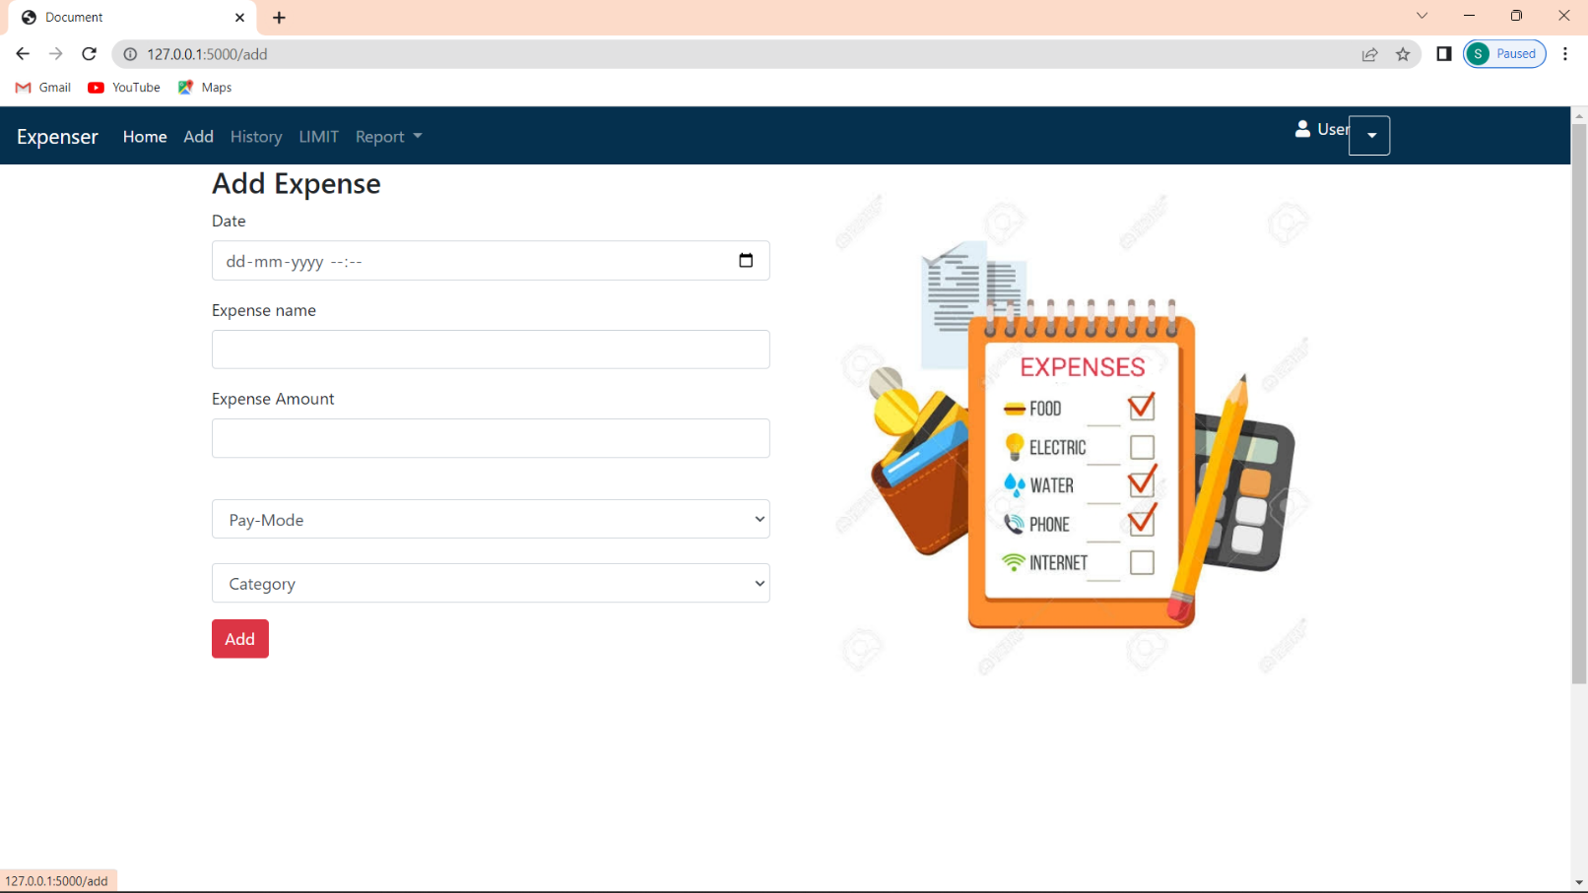

**9.6 Monthly limit**

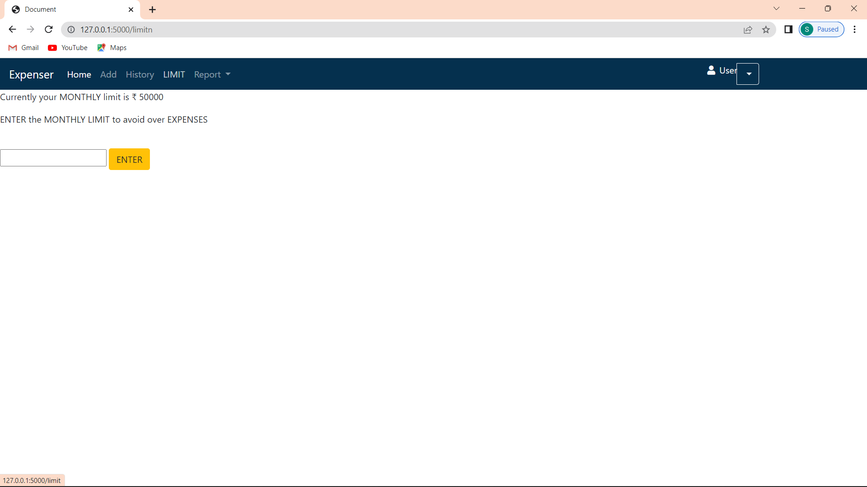**9.7 Expense category**

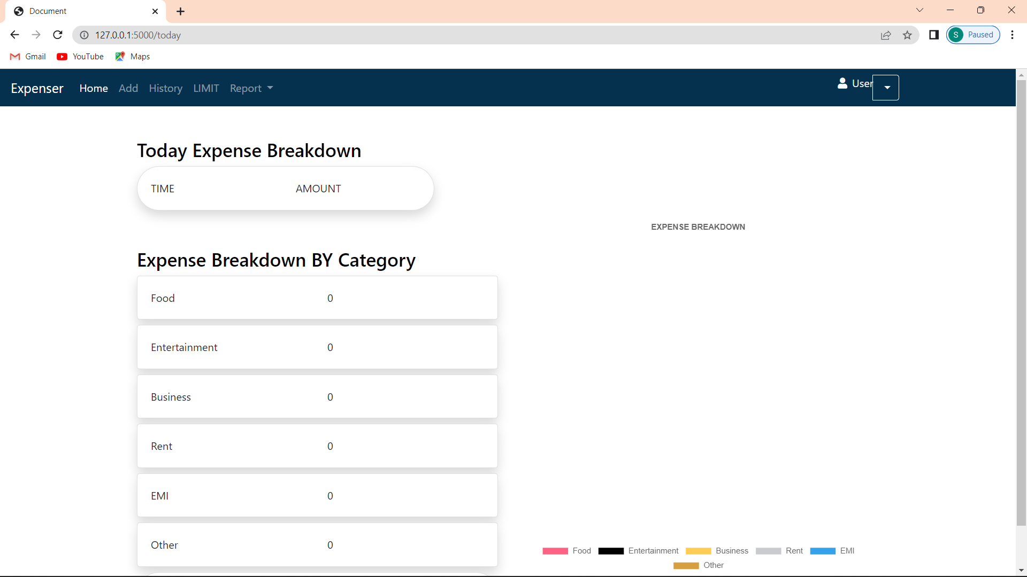**9.8 Setting limit**

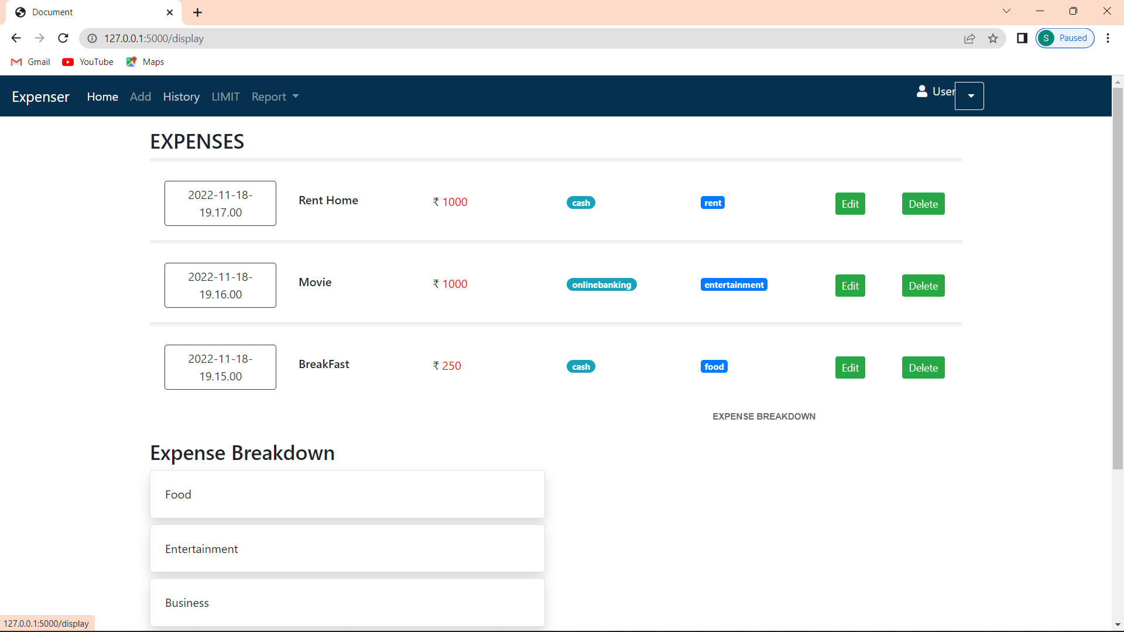

9.9 Result

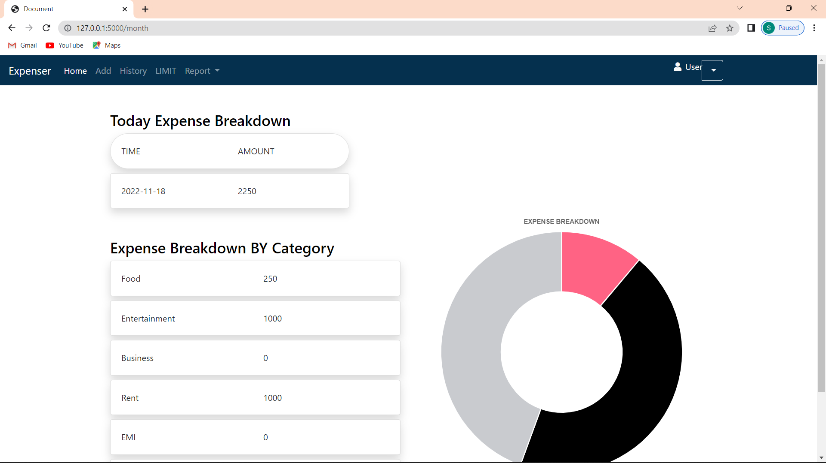

# ADVANTAGES AND DISADVANTAGES

**10.1. ADVANTAGES:**

As expending money is easier, we often fall prey to overspending. So, one of the immediate benefit of budgetingandexpense tracking is that, it preventsoverspending**.** Budgeting makes us aware of where we spend our money. Once we know this, it then helps us to fixalimit. Budgeting and expense tracking works like a control**.** It continuously gives us feedback about our spending patterns. This is what is called expense tracking. It makes us aware of how well we are performing on our different budgetedexpense heads. Using the Expense Manager, you can easily make month on month comparisons of earning, expenses and spending in a more organized manner.

**10.2. DISADVANTAGES:**

A con with any system used to track spending is that one may start doing it then taper off until it's forgotten about all together. Yet, this is a risk for any new goal such as trying to lose weight or quit smoking. If a person first makes a budget plan, then places money in savings before spending any new pay period or month, the tracking goal can help. In this way, tracking spending and making sure all receipts are accounted for only needs to be done once or twice a month. Even with constant tracking of one's spending habits, there is no guarantee that financial goals will be met. Although this can be considered to be a con of tracking spending, it could be changed into a pro if one makes up his or her mind to keep trying to properly manage all finances.

# CONCLUSION

The new system has overcome most of the limitations of the existing system and works according to the design specification given. The project what we have developed is work more efficient than the other income and expense tracker. The project successfully avoids the manual calculation for avoiding calculating the income and expense per month. The modules are developed with efficient and also in an attractive manner. The developed systems dispense the problem and meet the needs of by providing reliable and comprehensive information. All the requirements projected by the user have been met by the system. The newly developed system consumes less processing time and all the details are updated and processed immediately. Since the screen provides online help messages and is very user friendly, any user will get familiarized with its usage. Module s are designed to be highly flexible so that any failure requirements can be easily added to the modules without facing many problems. The best organizations have a way of tracking and handling these reimbursements. This ideal practice guarantees that the expenses tracked are accurately and in a timely manner.

# FUTURE SCOPE

* It will have various options to keep record (for example Food, Travelling Fuel, Salary etc.).
* Automatically it will keep on sending notifications for our daily expenditure.
* In today’s busy and expensive life, we are in a great rush to make moneys, but at the end of the month we broke off. As we are unknowingly spending money on title and unwanted things. So, we have come over with the plan to follow our profit.
* Here user can define their own categories for expense type like food, clothing, rent and bills where they have to enter the money that has been spend and likewise can add some data in extra data to indicate the expense.

**GitHub Link:**

**https://github.com/IBM-EPBL/IBM-Project-39169-1660398903**

**Demo Link:**

**https://youtu.be/XpQ7mtDe6Vc**